A000-AM,C-Costa Rica-Nicoya-Figure-Female-Whistle-Ceramic-Polychrome-Period V-VI-800-1000 CE

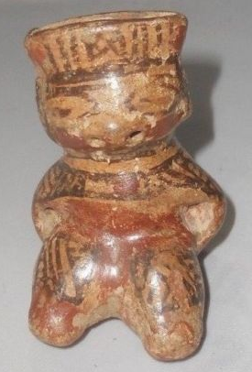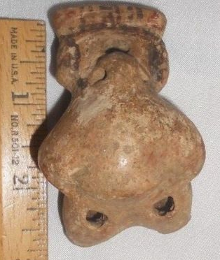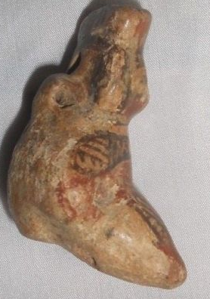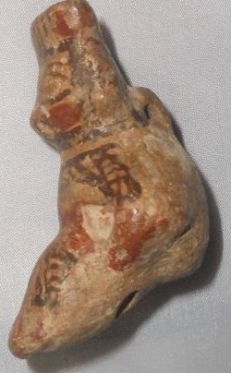

**Formal Label:** Costa Rica-Nicoya-Figure-Female-Whistle-Ceramic-Polychrome-Period V-VI-800-1000 CE

**Case No.: 14**

**Accession No.**

**Display Description:**

This polychrome female figure has linear and geometric body art and tattoos covering her shoulders and chest. She is posed seated suggesting an elevated social rank, and with her eyes closed as if in a trance this suggests that she is one of the ritual specialists with shamanistic powers. This figure is also a whistle and it may have been used to call those who were involved in meditative exercises.

**LC Classification:** F1545.3.A7

**Date or Time Horizon:** 800–1000 AD/CE

**Geographical Area:** Linea Vieja area, Costa Rica

**Map, GPS:** 10.741681, -85.481599, after https://www.google.com/maps/

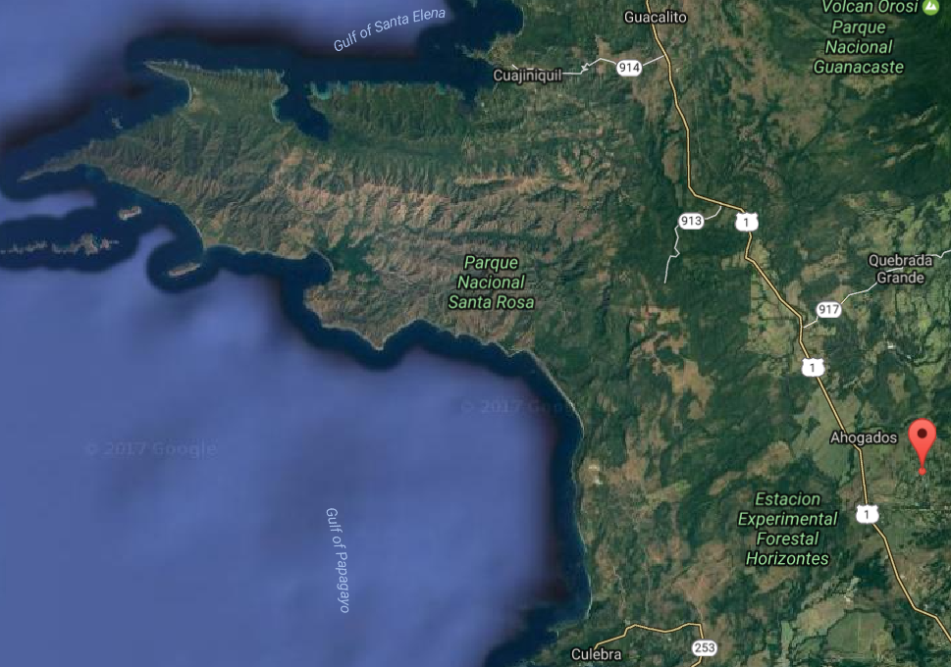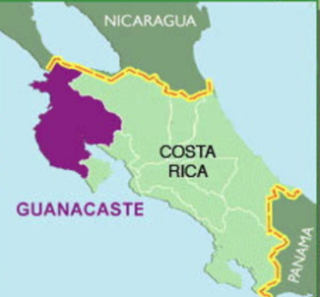

**Cultural Affiliation:** Guanacaste­-Nicoya

**Media:** terracotta, clay slip, red and black pigment.

**Dimensions:**

**Weight:**

**Condition: Original.** Some spalling on the surface shows the effects of moisture in the grave,

**Provenance:** Original.

Discussion:

This elaborately-painted, burnished and carefully hand-modeled seated female nude ceramic figure is portrayed with polychrome brown-on-cream-colored linear and geometric body art and tattoos covering her shoulders and chest. She is posed seated (suggesting an elevated social rank) with arms akimbo, hands resting on her torso with legs extended. She appears to be in a trance state with her eyes closed. There are five vent-holes; two at the nose, two at the femurs and one at the cervical base of the neck. Two suspension holes made this an amulet.

Guanacaste-Nicoya archaeological periods follow the periodization of Lower-Central America (Lange 1996) in six periods that spanned 12,000 BCE-1550 CE/AD. This polychrome ceramic comes from **Period V** (CE/AD 500-1000) in which there was a return to exploitation of marine resources, expanding habitations, and the development of Guanacaste-Nicoya polychrome ceramics of which this is an example in the Papagayo style: a cream-colored ceramic with polychrome motifs, which was widespread after 700 CE/AD. This ceramic with the figure’s eyes closed as if in a trance suggests she is one of the ritual specialists with shamanistic powers. It was probably placed in a grave in the Linea Vieja region where juxtaposed graves have stone-lined rectangular walls and floors that have preserved many ceramics in good to excellent condition (Stone 1972: 27).

**References:**

Abel-Vidor Suzanne, Dirk Bakker, Detroit Institute of Arts, Jay I. Kislak. 198. *B****etween continents/between seas: Pre-Columbian art of Costa Ri*ca.** New York: H.N. Abrams; [Detroit]: Detroit Institute of Arts.

Evans Toby, Susan and David Webster, eds. 2001. *Archaeology of Ancient Mexico and Central America: an Encyclopedia*. New York: Garland Publishing.

Lange, Frederick W., ed. 1996. *Paths to Central American Prehistory*. Boulder: University of Colorado Press.

Stone, Doris. 1972. *Pre-Columbian man finds Central America: the archaeological bridge*. Cambridge: Peabody Museum.

*Arts précolombiens de l’Amérique centrale dans les collections du musée Barbier-Mueller de Barcelone: Nicaragua, Costa Rica et Panamá,* 2001, cat. 9, p. 163

**Appendix:**

igure anthropomorphe assise  
Culture Nicoya  
Style Mora polychrome, Costa Rica  
Période V récente-Période VI ancienne, 800-1000 ap. J.-C.

NICOYA POLYCHROME SEATED FIGURE, COSTA RICA

**Estimate** http://www.sothebys.com/content/dam/default/lotSymbols/symb_DoubleDagger.gif

3,000 — 4,000

[EUR](http://www.sothebys.com/en/auctions/ecatalogue/2013/collection-barbier-mueller-pf1340/lot.246.html)

**LOT SOLD.** 9,375 EUR

[JUMP TO LOT](http://www.sothebys.com/en/auctions/ecatalogue/2013/collection-barbier-mueller-pf1340/lot.246.html#jumpToLotPopover)

